Unit 5 - EOCT Review
Form 501

Use the following figure for question 1.
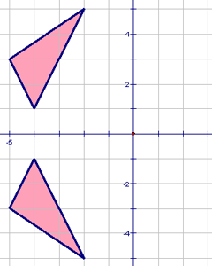
- Describe the transformation.
  - translation 6 units down
  - translation 2 units down
  - reflection across the x-axis
  - reflection across the y-axis

Use the following figure for question 2.
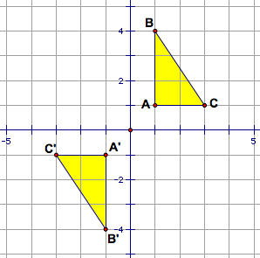
- Triangle ABC is reflected across the x-axis, and then across the y-axis. Which rotation is equivalent to this composition of transformations?
  - 45 degree rotation
  - 90 degree rotation
  - 180 degree rotation
  - 360 degree rotation
Use the following figure for question 3.
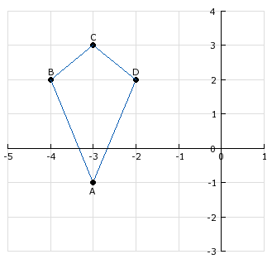
- If Kite ABCD is reflected across the x-axis, what are the resulting coordinates of point A?
  - (1, -3)
  - (-3, 1)
  - (3, -1)
  - (-3, -1)

Use the following figure for question 4.
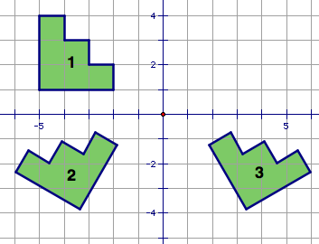
- The figure is transformed as shown in the diagram. Describe the transformation.
  - reflection, then rotation
  - rotation, then reflection
  - translation, then dilation
  - reflection, then translation
Use the following figure for question 5.
- Which triangle would be congruent to the original using a reflection over the x-axis and the y-axis?
Use the following figure for question 6.
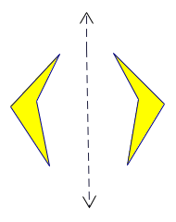
- Which type of transformation is shown here?
  - dilation
  - reflection
  - rotation
  - translation

Use the following figure for question 7.
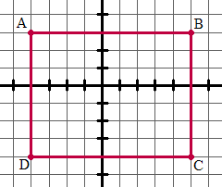
- You are given rectangle ABCD on the grid shown and are told that the figure is reflected, but you are not told over which axis this has occurred. Which COULD be the new coordinates of point D?
  - (4, -4)
  - (-6, -4)
  - (-2, -2)
  - (-1, -4)
Use the following figure for question 8.
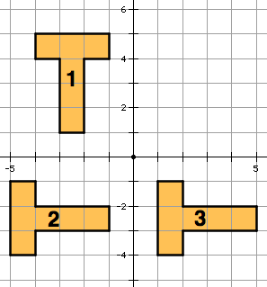
- The figure is transformed as shown in the diagram. Describe the transformation.
  - dilation, then reflection
  - reflection, then rotation
  - rotation, then translation
  - translation, then reflection

Use the following figure for question 9.
- Which type of transformation is shown here?
  - dilation
  - reflection
  - rotation
  - translation
Use the following figure for question 10.
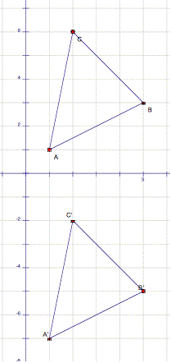
- The transformation of triangle ABC is an example of what?
  - Translation of (0, -8)
  - Translation of (0, 8)
  - A reflection across the y-axis
  - A reflection across the x-axis

- A triangle in the coordinate plane has coordinates of (2,3), (-4,-5), and (-2, 4). It is reflected about the y-axis. What are its new coordinates?
  - (-2,3), (4,-5), (2,4)
  - (-2,-3), (4,5), (2,-4)
  - (2,-3), (-4,5), (-2,-4)
  - (-2,-3), (-4,-5), (-2,-4)
Use the following figure for question 12.
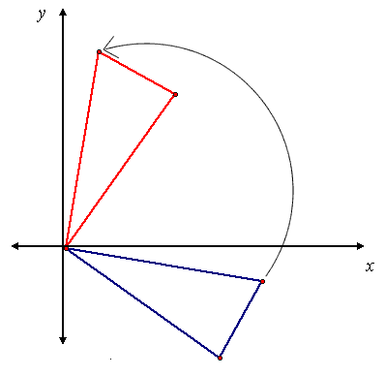
- A rotation in the origin is shown. The angle of rotation appears to be
  - 30°.
  - 45°.
  - 60°.
  - 90°.

Use the following figure for question 13.
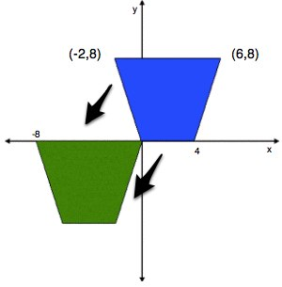
- When the upper right trapezoid is translated to the lower left one, the new coordinates of the point (0, 0) will be
  - (-6, -2).
  - (-2, -8).
  - (-8, -6).
  - (-6, -8).
Use the following figure for question 14.
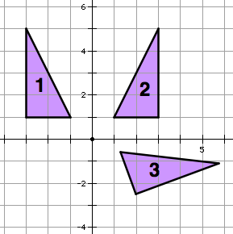
- The triangle is transformed as shown in the diagram. Describe the transformation.
  - dilation, then reflection
  - rotation, then reflection
  - reflection, then rotation
  - translation, then reflection

Use the following figure for question 15.
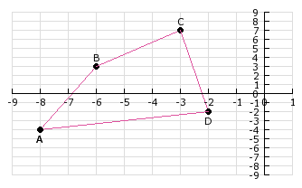
- Which transformation will move polygon ABCD completely into one quadrant?
  - up 5 units
  - left three units
  - reflect over the x-axis
  - reflect over the y-axis

