Unit 3 - EOCT Review
Form 302

Use the following graph for question 1.
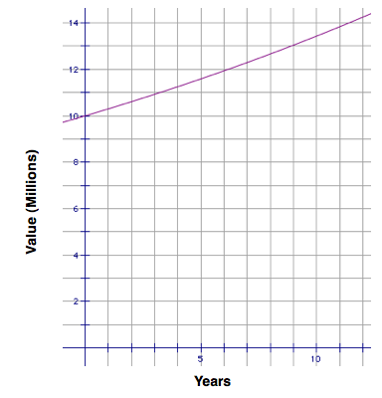
- Jonathan and Sarah purchased a beach house for $10,000,000. The home appreciates at a rate of 3% per year. The appreciation of the house is shown in the graph. The home is currently worth about $13,000,000. Jonathan and Sarah have owned the home for about ______ years.
  - 7
  - 9
  - 10
  - 11
Use the following graph for question 2.
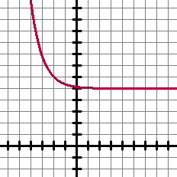
- Determine the domain of the graphed exponential function.
  - (-∞, ∞)
  - (-∞, 5]
  - (-∞, 5)
  - (-5, ∞)
Use the following table for question .
x-values | f(x) | g(x)
1 | 50 | 1.25
10 | 500 | 9.313
20 | 1000 | 86.736
30 | 1500 | 807.794
40 | 2000 | 7523.16

- The table shows values two functions evaluated at the same x-values. Which function will have the largest value as
x → ∞?
  - f(x)
  - g(x)
  - Neither; they will match
  - Neither; they are decreasing

- Heather was asked to graph 3x - y = -4 by using slope and y-intercept. Her graph is shown below.
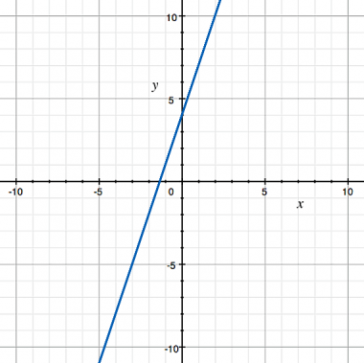
Which choice supports the graph that she has drawn?
  - The slope is positive 3 and the y-intercept is (0,4).
  - The slope is negative 3 and the y-intercept is (0,4).
  - The slope is positive 3 and the y-intercept is (0,-4).
  - The slope is negative 3 and the y-intercept is (0,-4).
Use the following graph for question 5.
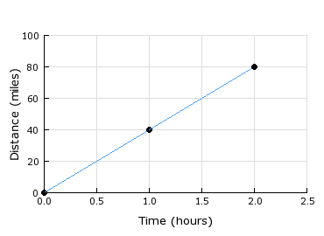
- The graph shows the distance a car travels at a constant speed. What is the speed of the car?
  - 20 mph
  - 40 mph
  - 60 mph
  - 80 mph

- A hair salon charges a fixed rate of $25.00 for a haircut and then an additional $15 for any other services. Write a function to model the cost of services there and then determine how many services you had if you were charged $115
  - f(x) = 15x + 25; f(6) = 115
  - f(x) = 25x + 15; f(6) = 165
  - f(x) = 15x + 25; f(115) = 1750
  - f(x) = 25x + 15; f(115) = 2890

Use the following graph for question 7.
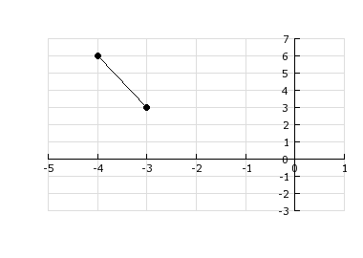
- Determine the coordinates of the x-intercept of the function shown in the graph.
  - (-6, 0)
  - (-2, 0)
  - (0, -2)
  - (0, -6)
- Two companies offer different charges for text messaging. Company 1 charges $0.06 per text message, while Company 2 charges rates according to the table.
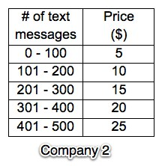
Which company offers the cheapest plan for 500 text messages?
  - Company 2, because the other company would charge $30.
  - Company 1, because the cost of 500 text messages is $25.
  - Company 2, because the cost of 500 text messages is $20.
  - Company 1, because the cost of each text message is only $0.06.

- Which of these tables does NOT represent a function?
  - 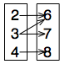
  - 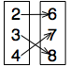
  - 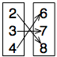
  - 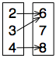
- The population of a certain single-cell organism doubles every hour, starting with 100 cells. Which COULD be an equation to model this situation, where f(t) is the number of organisms and t is time in hours?
  - $f\left(t\right)=200t$
  - $f\left(t\right)=100({2)}^{t}$
  - $f\left(t\right)=2t+100$
  - $f\left(t\right)=100{(\frac{1}{2})}^{x}$

- Which equation will shift the graph of the original equation ( y = 2x + 7 ) up 2 units?
  - y = 2x + 9
  - y = 4x + 7
  - y = 2x + 2
  - y = 2x - 2

- Which expression represents the number of dots for the nth member of the pattern?
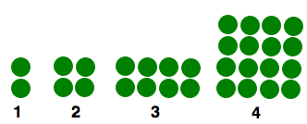
  - $n^{2}$
  - $2^{n}$
  - $\frac{n^{2}}{n}$
  - $n(n+1)$

- Which of these functions increases by 3 every time the x-increases by 1?
  - $y=3^{x}$
  - $y=3x+1$
  - $y={(\frac{1}{3})}^{x}$
  - $y=\frac{1}{3}x+1$
- Jeremy bought a new truck for $32,000. The value of the truck after t years can be represented by the formula V = 32,000(.8)^{t}. When will the truck be worth approximately $6700?
  - in 5 years
  - in 7 years
  - in 8 years
  - in 9 years

- The nth term of the sequence
-2, 1, 4, 7, 10,...
is given by the formula
  - a_{n} = n - 3
  - a_{n} = 3n - 3
  - a_{n} = n - 5
  - a_{n} = 3n - 5

- Write an equation that models the sequence 400, 200, 100, 50, ...
  - $y=\frac{1}{2}x+400$
  - $y=400(2^{x)}$
  - $y=50(2^{x)}$)
  - $y=400({\frac{1}{2})}^{x}$

- Greg sells cars. He makes a base salary of $25,000, plus $1500 per car he sells. The function that models this situation is
S = 1500x + 25000. After working at the car dealership for 2 years, he gets a raise. He now makes $1700 per car he sells. What is the new function that models this situation?
  - S = 1700x + 1500
  - S = 1500x + 1700
  - S = 1700x + 25000
  - S = 25000x + 1700
Use the following graph for question 18.
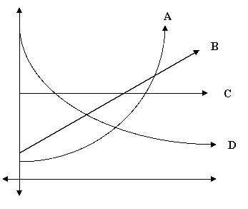

- You are going to model the growth of a population of bacteria which appears to be doubling every hour. Which graph is the BEST choice for doing this?
  - A
  - B
  - C
  - D

- The population of a small rural town in Iowa went from 5700 people in 1998 to 7945 in 2005. What is the rate of change in the population for this town?
  - -321 per yr
  - 321 per yr
  - 1135 per yr
  - 1825 per yr
- Andy and Sam are saving money to go on their senior trip. The amount of money that Andy will have at the end of each week, w, can be expressed as
A(w) = 20w + 300. The amount of money that Sam will have at the end of each week, w, can be expressed as
S(w) = 15w + 400. They have decided to combine their savings accounts. Write a function that expresses the total amount, T(w) they have in their savings account at the end of each week.
  - T(w) = 5w - 100
  - T(w) = 35w + 700
  - T(w) = -5w + 100
  - T(w) = 300w² + 12500w + 120000

