Coordinate Algebra Support
Form 202
EOCT Review Practice– Unit 2

Use the following graph for question 1.
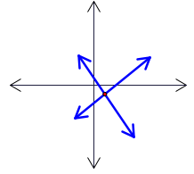
- A system of linear equations has been graphed in the diagram. Determine a reasonable solution for the system of equations.
  - (2, -1)
  - (-1, 2)
  - (-2, 1)
  - (0, -2)

- Match the following phrase to the correct mathematical expression:
two less than the product of y and 8
  - $8(y-2)$
  - $8y-2$
  - $\frac{y-2}{8}$
  - $\frac{y}{8}-2$

Use the following system for question 3.
$$\begin{matrix} y=x+2 \\ 2x-y=-4 \end{matrix}$$
- Solve the system of equations using substitution.
  - (-6,8)
  - (-6,-4)
  - (-2,-4)
  - (-2,0)
Use the following graph for question 4.
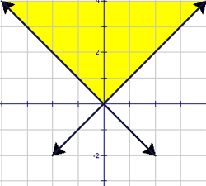
- Which system of inequalities is represented by the graph?
  - $\left\{\begin{matrix}y<-x \\ y<x\end{matrix}\right\}$
  - $\left\{\begin{matrix}y>-x \\ y>x\end{matrix}\right\}$
  - $\left\{\begin{matrix}y≤-x \\ y≤x\end{matrix}\right\}$
  - $\left\{\begin{matrix}y≥-x \\ y≥x\end{matrix}\right\}$

Use the following graph for question 5.
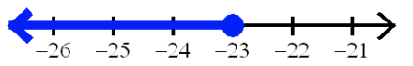
- Which inequality's solution is represented by the graph?
  - -2x + 6 ≤ 52
  - -2x + 6 ≥ 52
  - 2x + 6 ≤ -52
  - 2x - 6 ≥ -52

- Find the value of x when $5-x=\frac{1}{2}x+4$
  - -6
  - 2
  - $\frac{2}{3}$
  - $\frac{3}{2}$

Use the following system for question 7.
$$\begin{matrix} 3a+2b=2 \\ –2a+b=8 \end{matrix}$$
- Solve the system of equations.
  - (-2,4)
  - (4,-2)
  - (-4,-2)
  - $(\frac{5}{4},-\frac{1}{2})$

- Sarah is saving to buy a new phone. She needs $150, and she has already saved $63. Write an equation to model this situation. Let x represent the amount of money Sarah needs.
  - x - 63 = 150
  - x + 63 = 150
  - x + 150 = 63
  - x - 150 = 63

- Solve: 5 - 2x < 7.
  - x < -1
  - x > -1
  - x < -12
  - x > -12

- Solve: $4+\frac{x}{7}=2$
  - -14
  - 10
  - 12
  - 42

- Match the following mathematical equation to the appropriate phrase:
$$\frac{x}{5}+4=20$$
  - four more than x divided by 5 is 20
  - the sum of x and 4, divided by 5 is 20
  - x added to the quotient of 4 and 5 is 20
  - five divided by x plus four is 20
Use the following graph for question 12.
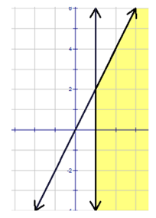
- Which system of inequalities is represented by the graph shown?
  - $\left\{\begin{matrix}x≥1 \\ y≤2x\end{matrix}\right\}$
  - $\left\{\begin{matrix}y>1 \\ y≤2x\end{matrix}\right\}$
  - $\left\{\begin{matrix}y>2x \\ y>1\end{matrix}\right\}$
  - $\left\{\begin{matrix}y<2x \\ x<1\end{matrix}\right\}$

Use the following information for question 13.
2(x + 7) + 3x = 12 | Given
2x + 14 + 3x = 12 | ?
5x + 14 = 12 | Simplify
5x = -2 | Subtraction Prop. of Eq.
$$x=-\frac{2}{5}$$ | Division Prop. of Eq.
- What is the missing reason?
  - Addition
  - Subtraction
  - Transitive Property
  - Distributive Property
Use the following graph for question 14.
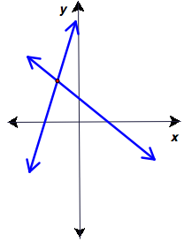
- A system of linear equations has been graphed in the diagram. Determine a reasonable solution for the system of equations.
  - (-2, 3)
  - (2, 3)
  - (2, -3)
  - (-2, -3)

Use the following system for question 15.
$$\begin{matrix} 3x-2y=10 \\ 5x+y=4\end{matrix}$$
- When solving this system of equations by elimination, which could be the resulting equation when a variable has been eliminated?
  - 13x = 18
  - -7x = 2
  - -7y = 62
  - 8x - y = 14
Use the following graph for question 16.
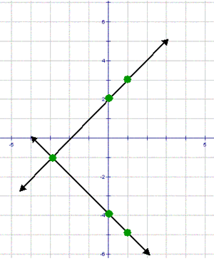
- Which of the sets of equations represents the two lines graphed?
  - y = x + 2 and y = x – 4
  - y = x + 2 and y = -x - 4
  - y = -x + 2 and y = x – 4
  - y = -x + 2 and y = -x - 4

Use the following system for question 17.
$$\begin{matrix} 2x-2y=6 \\ 3x+2y=9 \end{matrix}$$
- Solve the system of equations.
  - x = 0, y = 3
  - x = 3, y = 0
  - x = 1, y = -2
  - x = -2, y = 1

- Solve: 5y - 10 = -25.
  - y = -3
  - y = -7
  - y = 3
  - y = 7
Use the following graph for question 19.
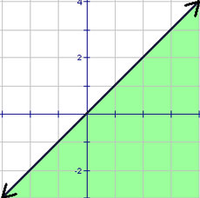
- The graph shown is for the inequality y ≥ x. The graph has one thing wrong. What is it?
  - The shading is on the wrong side of the boundary line.
  - The boundary line should be dotted or dashed.
  - The boundary line has the wrong y-intercept.
  - The boundary line has the wrong slope.
Use the following graph for question 20.
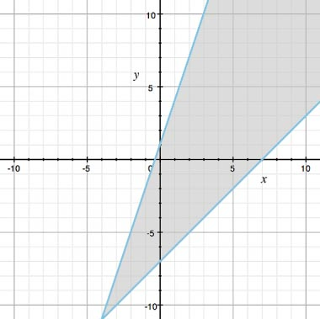
- Which system of inequalities is shown in the graph?
  - y > x – 7 and 3x – y > -1
  - y ≥ x – 7 and 3x – y < -1
  - y ≥ x – 7 and 3x – y ≥ -1
  - y ≤ x – 7 and 3x – y ≤ -1

