Coordinate Algebra Support
Form 102
EOCT Review Practice – Unit 1

Use the following graph for question 1.
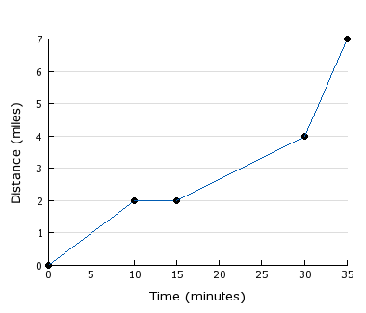
- The graph shows the relationship between time and distance for Shelly's trip to work. During what time period was the car stopped?
- 0 to 10 minutes
- 10 to 15 minutes
- 15 to 30 minutes
- 20 to 25 minutes

- Which expression represents the number of yards in x feet?
- $3x$
- $\frac{12}{x}$
- $\frac{3}{x}$
- $\frac{x}{3}$
Use the following graph for question 3.
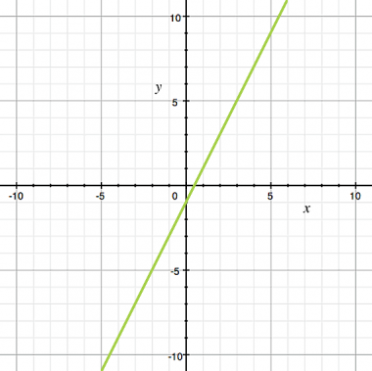
- The function shown in the graph is
- $f\left(x\right)=4x-1$
- $f\left(x\right)=2x-1$
- $f\left(x\right)=x-0.5$
- $f\left(x\right)=2x-0.5$

- Which expression is a DIFFERENCE?
- (6 - 4) x 5
- 6 - (4 x 5)
- 8 + (5 - 2)
- (6 - 4)(3 - 1)
Use the following information for question 5.
y = 192(.25) + .25x
y = 192(.25) + .25(56)
y = 48 +14
y = 62
- Jenny has been saving quarters in a piggy bank since she was born. She currently has 192 quarters in her piggy bank. She decides to add 56 more quarters and wants to find out how much money she has, so she can buy a $65 phone. She sets up and solves the equation above. What does her solution mean?
- She has a total of 62 quarters.
- She needs to save an additional $3.
- She needs to save 62 more quarters.
- She has a total of $62 in the piggy bank.

Use the following information for question 6.
t = # of text messages sent or received
- Before tax, and miscellaneous charges, Jason's cell phone bill is $100 per month plus $0.15 for every text message that he sends or receives. Which expression represents his cell phone bill for any given month?
- 100 + 15t
- 100 + 0.15t
- 0.15 + 100t
- 100t - 0.15t
- A school club is raising money for a trip, and needs to reach $10,000.
Their fundraising progress is modeled by the function
$f\left(x\right)=435+1200x$, where x is measured in weeks.
What is the meaning of the constant 435?
- It is the amount they started with.
- It is the amount still to be raised.
- It is the amount which is left over.
- It is the amount they raise each week.

- Five times the height of a kakapo minus 70 equal the height of an emu. If an emu is 60 inches tall, how tall is a kakapo?
- 24 inches
- 25 inches
- 26 inches
- 27 inches

- What is the coefficient in the expression (3m^{x})⁴+5?
- x
- 3
- 4
- 5
Use the following table to for question 10.
1996 | 10%
1997 | 10%
1998 | 11%
1999 | 12%
2000 | 13%
2001 | 12%
2002 | 13%
2003 | 14%
2004 | 13%
2005 | 15%

- Kyle is constructing a bar graph to display the percentage of students enrolled in AP courses from 1996-2005. He is planning to create a bar graph with a scale in 5% increments. Is this an appropriate choice given the data? Why or why not?
- No, he should construct a pie chart instead.
- No, he should use a scale with larger increments such as 0, 10, and 20.
- Yes; since his percentage does not go above 15% he can use a scale with 0, 5, 10, 15.
- No, because his percentages are so close together it will be difficult to determine differences in the years if he uses a scale of 5% increments. He should use a smaller scale such as 1% increments.
Use the following graph for question 11.
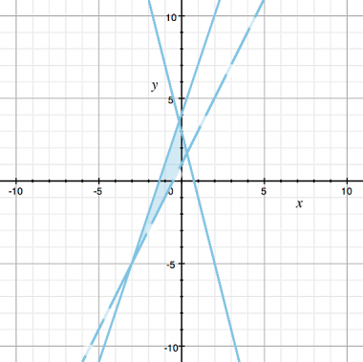
- The solution set to the system of inequalities is graphed. What is wrong with the graph?
$$2x-y>-1$$
$$3x-y≤-4$$
$$4x+y≥3$$
- The wrong region is shaded.
- Nothing, the graph is correct.
- The line(s) are graphed incorrectly.
- One line should be solid and the other dotted.
- George asked five of his friends how long they studied for the last math test and what grade they received. He found a linear regression equation for the data to be y = 9.6x + 65.8. What does the 9.6 mean in the context of this equation?
- That his friends on average studied 9.6 hours.
- That if they studied 9.6 hours they would get a 0 on the test.
- That they should study 9.6 hours in order to get an A on the test.
- That for every hour they studied their grade would go up 9.6 points.

- Devon has 14 steel balls of equal weight. If he puts 8 of them in one pan of a balance, and the rest along with a weight of 20 grams in the other pan, the pans balance each other. Which equation can be used to find the weight of each steel ball?
- 8x = 26x
- 8x = 120x
- 8x + 20 = 6x
- 8x = 6x + 20
- Given A = bh solve for b.
- $b=Ah$
- $b=\frac{h}{A}$
- $b=\frac{A}{h}$
- $h=\frac{A}{b}$

- Austin's office is 360 square feet. Calculate the area of his office in square yards.
- 1080 square yards
- 120 square yards
- 60 square yards
- 40 square yards

Use the following table for question 16.
x | y
0 | -7
1 | -4
2 | -1
3 | 2
4 | 5

- Which equation corresponds to the function described in the table?
- y = x - 7
- y = x - 3
- y = x - 1
- y = 3x - 7

- Which expression is a SUM?
- 5(2 + 3)
- 8 x (6 + 3)
- 5(2) + 2(6 ÷ 3)
- (5 + 2) ÷ (2 + 3)
- At a high school football game Jamie buys 6 hot dogs and 4 soft drinks for $13. Amy buys 3 hot dogs and 4 soft drinks for $8.50. What is the price of a hot dog?
- $0.75
- $1.00
- $1.25
- $1.50

- The perimeter of a triangle is given by the formula P = a + b + c. Solved for b, this formula becomes b =
- P + a + c
- P - a - c
- P + a - c
- P - a + c

- How many feet are equivalent to ¼ mile?
- 9
- 250
- 1,320
- 1,455

